Czech Karate Federation
Pilsen Karate Federation

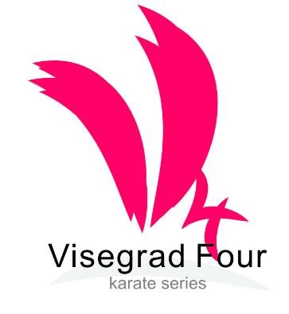

23rd
Czech Karate Open
Euro Grand Prix
For Children, Youth and Seniors

4th – 5th November, 2023

Pilsen (Plzeň)
Czech Republic
City Sports Hall, Krasovska street

Dear Friends,

We would like to invite you to the biggest international tournament in karate for youth and adults, which is held in the Czech Republic.
The tournament, which started its own history at the turn of the millennium in the year 2000, attracted in the last years European and World elite and became highly sought as a preparatory tournament for many national federations.

We are very happy to welcome the karate family from the whole World to be the hosts of one of the great sporty cities in the Czech Republic. City of Pilsen, where many famous athletes and sport stars were trained, not only in karate, but from a very wide variety of sports.

We are proud that the tournament has been held more than twenty times, once again this year in the city of Pilsen. But, now is the time for celebration of sport and culture, of course tasty food and astounding beverages are one of our biggest enticements for all participants of this tournament.

Therefore once again, we would like to invite you to this event and we are looking forward to your participation.

Sincerely,

Marek Kubin
Chairman of Organizing committee

Competition Venue (New venue)

Opened April 2023

City sporthall Krasovska
Krasovska 32, Plzen

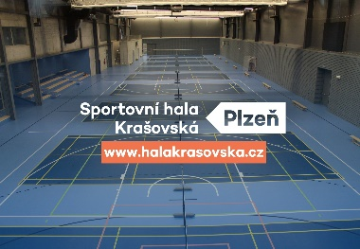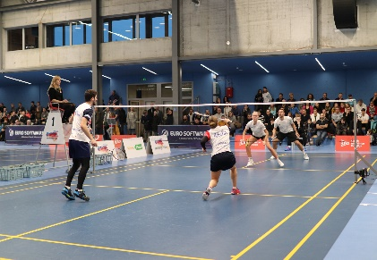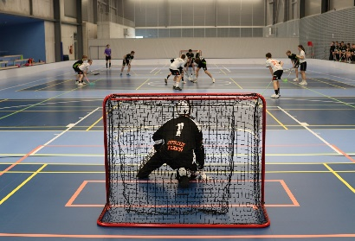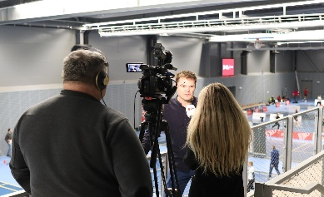

Here is the location of a new place of the tournament

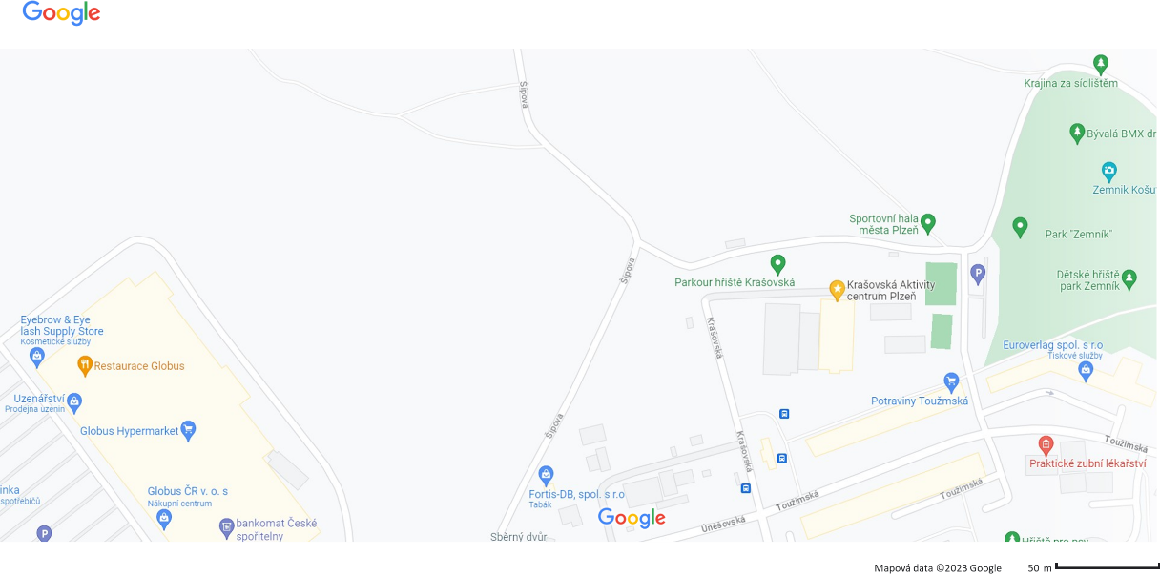
Categories

Cadets, U21,

Cadets Kata cadet male, female
14-15 years Kumite cadet female -47, -54, -61, +61kg
Kumite cadet male -52, -57, -63, -70, +70kg

U21 Kata U21 male, female
18-20 years Kumite U21 female -50, -55, -61, -68, +68 kg
Kumite U21 male -60, -67, -75, -84, +84 kg

Juniors, children

Juniors Kata junior male, female
16-17 years Kumite junior female -48, -53, -59, -66, +66kg

Kumite junior male -55, -61, -68, -76, +76kg

12-13 years Kata U14 female, male
Kumite U14 female -42, -47, -52, +52kg

Kumite U14 male -40, -45, -50, -55, +55kg

Tournament system

All categories will take place divided in two parts:
- Group phase (always at least 4-member group, system round robin)
- Elimination phase (always the first or the first two of the group will create a quarterfinals and afterwards in an elimination way with a repechage for two third places, until the final)

Group stage - kata

Each participant will perform kata in a two-round system, where both results are summed up and the order is determined by the simple sum of both rounds. In case of compliance, the WKF rules are followed.

Group stage – kumite

Each match will be evaluated, for a victory on points - 3 points, a victory on Senshu (score is the same) 2 points, a loss on Senshu (score is the same) or a hikiwake 1 point, a loss will grant 0 points.
Progressing will be the group victor. In case of an agreement, the WKF rules for the round robin competition will be followed.

The elimination phase is determined as the system for Premier League tournaments, if the number of quarterfinalists will not be filled, it will be given in this case as a free place.

For the kata competition, two groups will be created for the selection for medals and then there will be a medal match phase. A maximum of 4 katas is required for the tournament.

Division into the groups will be according to the possibilities and WKF ranking and further according to the representation of the countries, in order to ensure the greatest possible objectivity of the tournament...

Rules

New competition rules WKF(1.1.2023) and changes from this bulletin.

Kata

U14, cadets, juniors, U21, seniors – tokui kata by WKF rules kata list (1.1.2023). Cadets, juniors, seniors, U21 will have new system selections

Kumite

Children

12-13 years competition time - match 90 sec., tatami 8*8 meters
WKF rules for category cadets

Cadets, juniors, U21, seniors - WKF rules (1.1.2023)

Equipments

Obligatory equipment for all categories (approved type WKF, EKF or national federation)
- Gum shields
- Shin protectors blue and red
- Feet protectors blue and red
- gloves blue and red
- Body protector
Categories male and boys - Groin protector (obligatory )

Non obligatory, but accepted for categories 12-13 years
- Facemask or helmed approved by WKF

The start in two age categories is possible, but here follows a special system for this case:

Junior U21 kata

Another start isn´t possible.
Participation in kata in only two categories. It is not possible to start from 16 years in all categories (junior, U21, Seniors).

Payment entry fee is per competitor and category. No sales or cumulative offers.

All participation changes and starts you must do on a registration page via www.sportdata.org. Any changes after the deadline, will be subject to a payment of extra 50 Euro per entry.

Any manipulation of the date of birth is prohibited!! If it is found, the competitor is to be disqualified before, during and also after the tournament. Including the possibility of further sanctions in the future editions of the tournament.

All categories can be changed by the organizer of the competition. Date for the tournament is a date before it´s the 5th of November 2023. Possible start another category if prepare competitor on ECH 2024.

Entry fee:
50 Euro per competitor and category – payment only via bank transfer

Bank transfer:
Bank account nr: 2300984207
IBAN: CZ6620100000002300984207 BIC/SWIFT: FIOBCZPPXXX
Name: Club karate Plzen z.s.
Fio banka a.s., Millennium Plaza, V Celnici 10, Praha 1,11721

Participants:

All the European and World clubs

Entries:

On-line by website sportdata.org. No later than the 25th of October 2023.

Maximum will be 700 entries.

If the limit is filled before the deadline, the system will only accept through a waiting list and so everyone will be informed by the organizer if they will be accepted into the tournament.

The fee may be directly transferred to the bank account in advance or on site with the fee paid in cash.

If you pay by cash, you must pay an extra fee of 50 Euro per entry.

The team has to pay on the spot for all competitors who have registered. If there is a failure to do so, they will not be admitted to the tournament. With a credit transfer, this rule does not apply.

Referees : Referees and judges will be invited by the organizer with a VIP invitation letter

Protest: Payment to OC, 400 Euro

Tournament schedule

Will be announced later…….

Time schedule by tatami, by categories and all other time information, will be announced 2 days before the start of the tournament, after finishing the registration.

Everything will be on www.sportdata.org or web site of the tournament.

You haven't registered – control of a passport (another document isn´t valid). If you make all your payments, you can go inside the sporthall one hour before the start of your category by time schedule from the sportdata system.

We are not a qualification tournament – weighting is randomized, only one or two competitors from each category, before the start of the category on tatami via time schedule.

Accomodation:

Accomodation 23nd EGP 4.-5.11.2023

All information contact to person Mr. Hazuka Tomas
Mail: hazukovo@gmail.com
Phone: +420 739065586

Capacity of the hotel rooms and names of official hotels are provided by the organizer team, directly for your team! We can prepare special prices in the three categories of quality.

Transport

We will transport your teams from the airport Vaclav Havel in Prague into the official hotels and back for a fee of 40 Euro per person.

To ensure transport, it is necessary to fill the table below:

Transport from the official hotels to the sports hall is free for the duration of the tournament and will be provided throughout the day, in every hour or two intervals.

More detailed timetable will be published on the website of the tournament, the www.sportdata.org website and inside all of the partner and official hotels.

All buses, minibuses or cars will carry the logo of the tournament

Marek Kubín Jan Pytlík Organizing Commission president
of The Pilsen Karate Federation
e-mail: kubin@karatecz.cz e-mail: pytlik@karatecz.cz

