***Czech Karate Federation***

***Pilsen Karate Federation***



 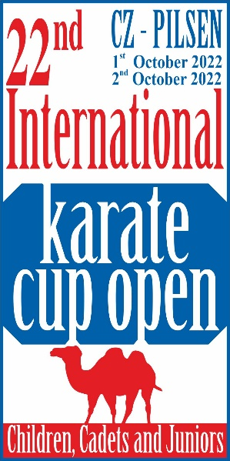 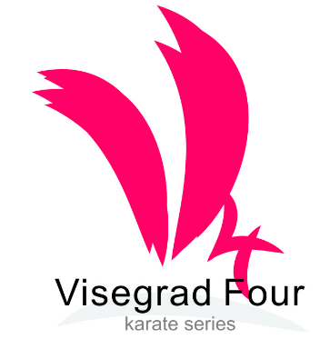

**The 22nd**

**Czech** **Karate Open**

**Euro Grand Prix**

**E-karate tournament**

# *For Children, Youth and Seniors*

## **1st – 2nd October, 2022**

Pilsen (**Plzeň**)

Czech Republic

*City Sports Hall, Úslavská street*

Dear Friends,

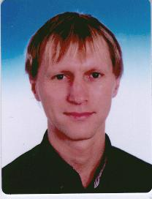

We would like to invite you to the biggest international tournament in karate for youth and adults, which is held in the Czech Republic.  
The tournament, which launched its own history at the turn of the millennium in 2000 , found in the last years of European and world elite and became highly sought after preparatory tournament for many federations.

We are very happy to welcome family karate from around the world that will host one of the great sports towns in the Czech Republic. City of Pilsen trained many famous athletes and stars not only karate , but from a very wide field of sports .

We are proud that the tournament has been held for more than the twenthy time , when this year the city of Pilsen. We invite all team in this hard time – Covid -19. Now is time for celebration of sport and culture, and of course a good drink is our biggest draw for all participants in this tournament .

Once again, therefore we would like to invite you to this event and look forward to your participation.  
  
Sincerely,

Marek Kubin

Chairman of Organizing committee

**Competition place**

Congress centrum Parkhotel Plzeň – main place

U Borského parku

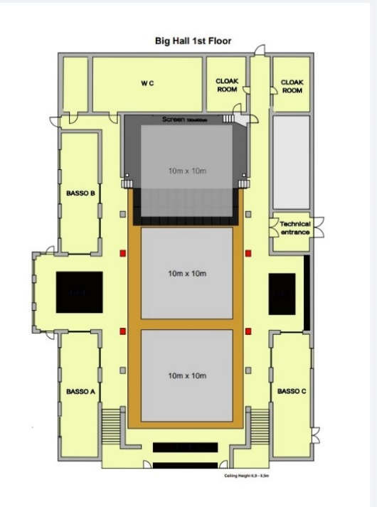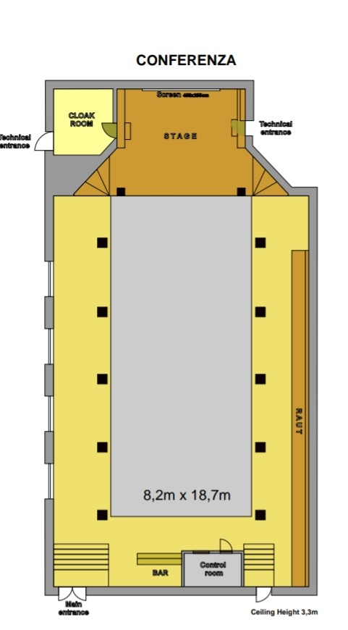

[Here in location new place tournament](https://www.google.com/maps/@49.720588,13.370984,17z)

Categories

**Cadets, U21,**

Cadets Kata cadet male, female

14-15 years Kumite cadet female -47, -54, +54kg

Kumite cadet male -52, -57, -63, -70, +70kg

U21 Kata U21 female, male

18-20 years Kumite U21 female -**50, -55, -61, -68, +68 kg**

Kumite U21 male -60, -**67, -75, -84, +84 kg**

**Juniors, children**

Juniors Kata junior female, male

16-17 years Kumite junior female -48, -53, -59, +59kg

Kumite junior male -55, -61, -68, -76, +76kg

12-13 years Kata U14 female, male

Kumite U14 female -42, -47, +47kg

Kumite U14 male -40, -45, -50, -55, +55kg

**Tournament system**

All categories will take place in two parts:

1. Group phase (always at least 4-member group system round robin)

2. Elimination phase (always the first or the first two of the group create a quarterfinals and from there in an elimination way with a replay of two third places until the final)

Group stage - kata

Each participant will perform kata in a two-round system where both results are summed and the order is determined by the simple sum of both rounds. In case of compliance, the WKF rules are followed.

Group stage – kumite

Each match will be evaluated for a victory on points 3 points, a victory on Senshu (score is the same) 2 points, a loss on Senshu (score is the same) or a hikiwake 1 point, a loss of 0 points.

Progress is a group victory. In case of agreement, the WKF rules for the round robin competition are followed.

The elimination phase is determined by the system for Premier League tournaments, where the number of quarterfinalists will not be filled, it will be forwarded in this case as a free place.

For the kata competition, two groups will be created for selection for medals and then there will be a medal match phase. A maximum of 4 katas is required for the tournament

Deployment to the groups will be according to the possibilities and ranking of the WKF and further according to the representation of the states, in order to ensure the greatest possible objectivity of the tournament...

**Rules**

***New competition rules WKF(1.1.2020) and changes from this bulletin.***

**Kata**

U14, cadets, juniors, U21, seniors – tokui kata by **WKF rules kata list** (1.1.2020). Cadets, juniors, seniors, U21 will be new system selections,

**Kumite**

Children

12-13 years time competiton match 90 sec., tatami 8*8 meters

WKF rules for category cadets

Cadets, juniors, U21, seniors - WKF rules (1.1.2020)

**Equipments**

**Obligatory equipments for all categories** (approved type WKF,EKF or national federation)

* Gum shields
* Shin protectors blue and red
* Food protector blue and red
* Hand protector blue and red
* Body protector

Categories girls and female - Chest protector (obligatory together with body protector)

**Non obligatory, but accepted for categories 12-13 years**

* Facemask approved WKF
* Suspenzor (all men categories)

They can start on two age categories is possible, but here is special system for this:

Junior U21 kata

**Another start isn´t possible.**

**Start in kata only two categories. Don´t possible start from 16 years all categories.**

Payment entry fee is per competitor and category. No sales ,no cumulations.

All changes and start you must on registration by [www.sportdata.org](http://www.sportdata.org). Any changes after stop will be payment to extra money 30 Euro per entries.

**Any manipulation of date of birthday is prohibited!!** If it is found to be **disqualified before, durind and after the tournament**. Including the possibility of futher sanctions in future editions tournaments.

All categories can be changes by organizer by full the competition.

Date for category is date WKF World championship Konya tournament it´s 26**th October 2022**.

**Entry fee:**

**30** Euro per competitor and category – **payment only by bank transfer**

**Bank trasfer:**

**Bank account nr: 2300984207**

**IBAN: CZ6620100000002300984207**

**BIC/SWIFT: FIOBCZPPXXX**

**Name: Club karate Plzen z.s.**

**Fio banka a.s., Millennium Plaza, V Celnici 10, Praha 1,11721**

**Partcipants:**

All european and world clubs

**Entries:**

**On-line by website** [**sportdata.org**](https://www.sportdata.org/karate/set-online/veranstaltung_info_main.php?active_menu=calendar&vernr=3414#a_eventheadend)**. No later then 25th September 2022.**

**Maximum is 700 entries.**

If the limit is filled before the system will only accept the waiting list and everyone will be informed by the organizers that will be accepted into the tournament.

Payment of fee may directly transfer the amount to the bank account in advance or on the spot with the fee payment in cash.

If you pay by cash, must pay extra fee 30 Euro per entry.

The team will pay on the spot cash for all competitors have registered. Failure to do so will not be admitted to the tournament. Credit transfer, this rule does not apply.

Referees : Referee and judges will invite organizer by VIP invitation letter

**Protest:** payment to OC 200 Euro

##### Tournament schedule

Will be later…….

Time schedule by tatami by categories and all time informations, will be 2 days before start tournament after finishing registration.

Every this will be on [www.sportdata.org](http://www.sportdata.org) or [web site tournament](http://www.karatecup.cz/).

We haven´t registration – control by passport (another document isn´t valid). If you make all payment, you can go to sporthall one hour before start category by time schedule from sportdata systém.

We not qualification tournament – weighting is only some one or two competitors from category, before start on tatami by time schedule.

***Accomodation:***

|  |  |  |  |
| --- | --- | --- | --- |
|  | ***Accomodation 22.****nd* ***EGP 1.-2.10.2022*** |  |  |

All information contact to person Mr. Hazuka Tomas

Mail: [hazukovo@gmail.com](mailto:hazukovo@gmail.com)

Phone: +420 739065586

**Capacity hotel rooms and names official hotels send organizer team directly for your team! We prepare special prices in the three categories quality.**

**Transport**

We transport our teams from the airport Vaclav Havel in Prague in the official hotels and back for a fee of **30** Euro per person.

To ensure transport is necessary to fill the table below.

|  |  |  |  |  |  |  |  |  |  |  |  |
| --- | --- | --- | --- | --- | --- | --- | --- | --- | --- | --- | --- |
| *Date arrival* | *Time arrival* | *Nr. flight* | *Company* | *destination* | *Nr. person* | *leader* | *country* | *hotel* | *terminal* | *Date departure* | Time departure |
|  |  |  |  |  |  |  |  |  |  |  |  |

Transport from the official hotels to the sports hall is free for the duration of the tournament and will be provided throughout the day at hourly or two-hourly intervals.   
  
More detailed timetable will be published on the website of the tournament, the registrar www.sportdata.org and in all the partner and the official hotels.   
  
All buses, minibuses or cars will carry the logo of the tournament

Marek Kubín Jan Pytlík

Organizing Commission president

of The Pilsen Karate Federation

e-mail: [kubin@karatecz.cz](mailto:kubin@karatecz.cz) e-mail: [pytlik@karatecz.cz](mailto:pytlik@karatecz.cz)