***Czech Karate Federation***

***Pilsen Karate Federation***

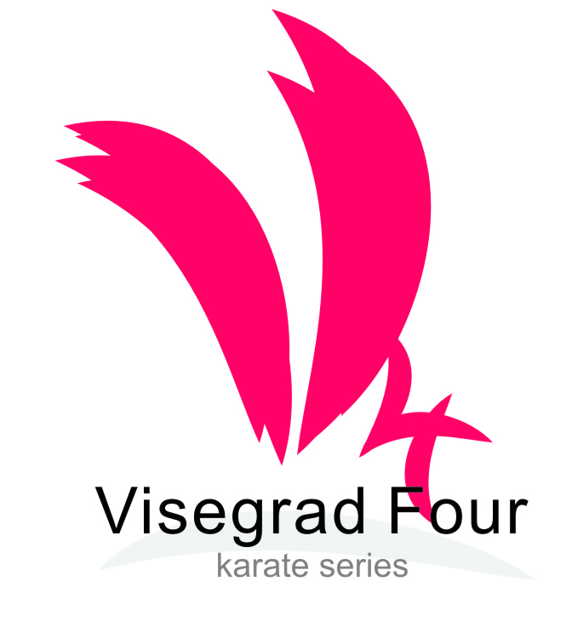

**The 18th**

**Czech** **Karate Open**

**Euro Grand Prix**

**Visegrad four series**

# *For Children, Youth and Seniors*

## **30th September – 1st October, 2017**

Pilsen (**Plzeň**)

Czech Republic

*City Sports Hall, Úslavská street*

Dear Friends,

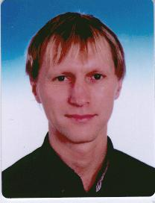

We would like to invite you to the biggest international tournament in karate for youth and adults, which is held in the Czech Republic.  
The tournament, which launched its own history at the turn of the millennium in 2000 , found in the last years of European and world elite and became highly sought after preparatory tournament for many federations.

We are very happy to welcome family karate from around the world that will host one of the great sports towns in the Czech Republic. City of Pilsen trained many famous athletes and stars not only karate , but from a very wide field of sports .

We are proud that the tournament has been held for the seventeenth time , when this year the city of Pilsen , was last year the European City of Culture. A right combination of sport and culture, and of course a good drink is our biggest draw for all participants in this tournament .

Once again, therefore we would like to invite you to this event and look forward to your participation.  
  
Sincerely,

Marek Kubin

Chairman of Organizing committee

**Words of the ViceMayor of the City of Pilsen on the 18th Karate Euro Grand Prix**

It is an honour for the City of Pilsen to host a prestigious competition of young karate fighters Euro Grand Prix.

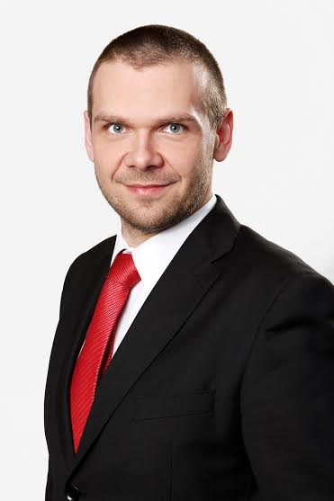

Although I cannot master karate I am aware that this old Asian martial art is a demanding and attractive sport discipline and it is pleasing that a lot of young people go in for it. I think that young people learn discipline, tenacity, fast reactions and movement abilities when doing karate. If it is used and trained according to methods of ancient Japan martial art masters it leads to creating of character, to strengthening of self-restraint and to responsibility. It is a kind of sport which develops physical and intellectual qualities.

I wish the Pilsen tournament every success, very good and fascinating performances, great public interest and a largest possible number of participants who I greet sincerely in our city.

Jime.

Mgr. Martin Baxa

ViceMayor of the City of Pilsen

Dear athletes, coaches, referees and supporters karate,

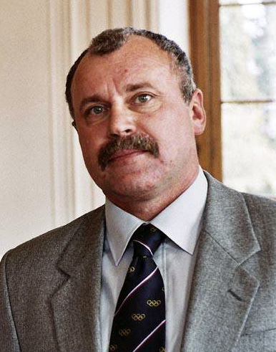

Let me add my invitation to the traditional karate tournament for youth in Pilsen.

Our Foundation has for many years supported the growth not only of your sport, but a lot of other sports, they work well as enthusiasm for the future, ie with children and youth.

It is symbolic that Pilsen, which has in its ranks a wide range of athletes at all levels, supports just your sport, which is probably best known for Pilsen natiwe Petra Nova .

Therefore, I would like to wish the organizers of the nerves and calm the athletes success enthusiasm and vigor, coaches a good strategy and impartiality of the judges and a sharp eye.

Good luck

Mgr. Frantisek Berka   
Chairman of the Board of Youth sport foundation

**Competition place**

City sporthall (Lokomotiva) Pilsen

Úslavská str.

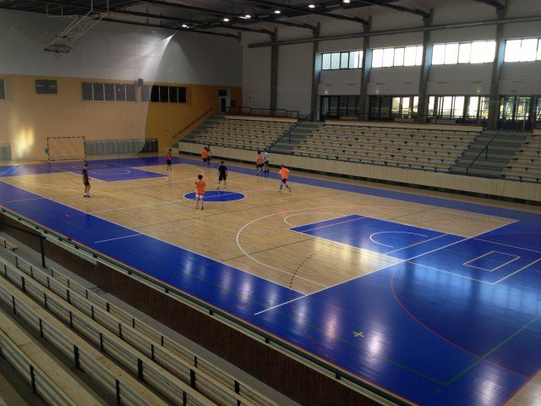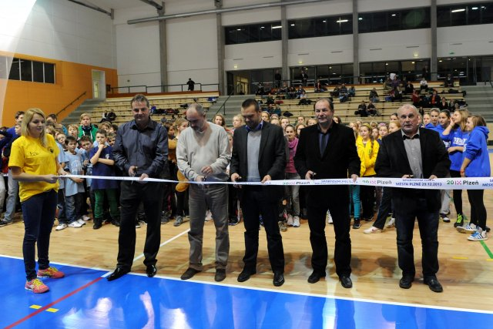

Sporthall after reconstruction now is in full function. Here is on [Youtube](http://www.youtube.com/watch?v=ymMTFs7uYDM&list=PLWmhcu8sX-74G4ZBaW0qXFmWiRidzA4Su) all visit opening ceremonial.

Here is map another places on the sporthall [informations](https://maps.google.cz/maps?hl=cs&q=m%C4%9Bstsk%C3%A1+sportovn%C3%AD+hala+plze%C5%88&gbv=2&ie=UTF-8&ei=BNpxU-CDF4eM7Qbc5ID4CA&ved=0CAkQ_AU)

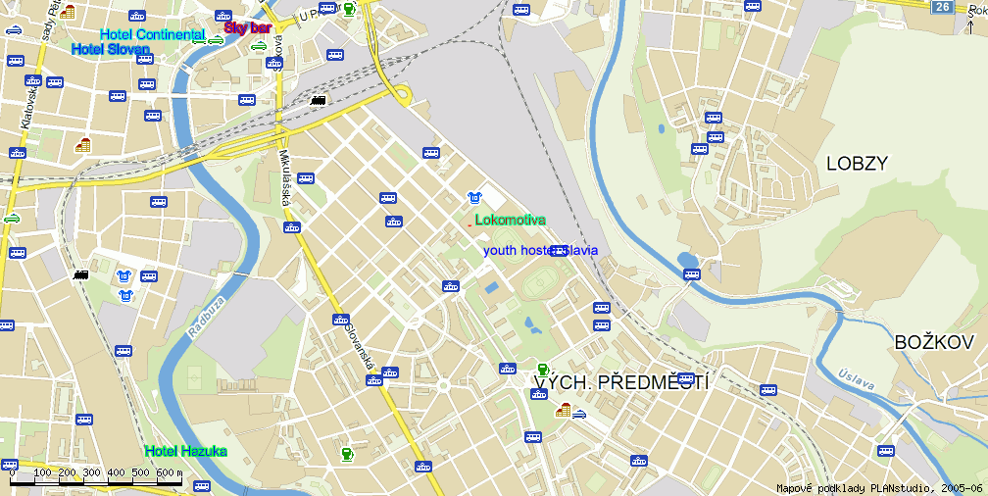

Categories

**Saturday 30th Setember 2017**

**Cadets, U21, seniors**

Cadets Kata Cadet female, male

14-15 years Kumite cadet female -47, -54, +54kg

Kumite cadet male -52, -57, -63, -70, +70kg

U21 Kata female, male

18-20 years Kumite female -53, -60, +60kg

Kumite male -68, -78, +78kg

Seniors Kata female (up 16 years)

18 and older Kata male (up 16 years)

Kumite female -50, -55, -61, -68, +68kg

### Kumite male -60, -67, -75, -84, +84kg

**Sunday 1st October 2017**

**Juniors, children**

Juniors Kata junior female, male

16-17years Kumite junior female -48, -53, -59, +59kg

Kumite junior male -55, -61, -68, -76, +76kg

Children

9-11 years Kata girls, boys

Kumite girls -35, +35kg

Kumite boys -32, -40, +40kg

12-13 years Kata girls, boys

Kumite girls -50, +50kg

Kumite boys -45, -55, +55kg

**Rules**

***New competition rules WKF(1.1.2017) and changes from this bulletin.***

**Kata**

Children 9-11 years Tokui kata by WKF rules, one time repeated kata any round

Both competitors practicing together. Medal both and semifinal separatly.

Children 12-13 years Tokui kata by WKF rules, each round diferently kata.

Both competitors practicing together. Medal both and semifinal separatly..

Cadets, juniors, U21, seniors – tokui kata by WKF rules without changes (1.1.2017).

**Kumite**

Children

9-11 years time competiton match 60 sec., tatami 6*6 meters

WKF rules for category cadets

12-13 years time competiton match 90 sec., tatami 8*8 meters

WKF rules for category cadets

Cadets, juniors, U21, seniors - WKF rules (1.1.2017)

**Equipments**

**Obligatory equipments for all categories** (approved type WKF,EKF or national federation)

* Gum shields
* Shin protectors blue and red
* Food protector blue and red
* Hand protector blue and red
* Body protector

Categories girls and female - Chest protector (obligatory together with body protector)

**Non obligatory, but accepted for categories 9-11, 12-13 years**

* Facemask approved WKF
* Suspenzor (all men categories)

They can start on two age categories is possible, but here is special system for this:

Children 9-11 years children 12-13 years only kata

Children 12-13 years cadet kata+ kumite

Cadet Junior kata + kumite

Junior U21 kata + kumite

U21 Senior no restriction

**Another start isn´t possible.**

**Start in kata only two categories. Don´t possible start from 16 years all categories.**

Payment entry fee is per competitor and category. No sales ,no cumulations.

All changes and start you must on registration by [www.sportdata.org](http://www.sportdata.org). Any changes after stop will be payment to extra money 20 Euro per entries.

**Any manipulation of date of birthday is prohibited!!** If it is found to be **disqualified before, durind and after the tournament**. Including the possibility of futher sanctions in future editions tournaments.

All categories can be changes by organizer by full the competition.

Date for category is date tournament it´s **1st October 2017**.

**Entry fee:**

20 Euro per competitor and category

**Bank trasfer:**

**Bank account nr: 2300984207**

**IBAN: CZ6620100000002300984207**

**BIC/SWIFT: FIOBCZPPXXX**

**Name: Club karate Plzen z.s.**

**Fio banka a.s., Millennium Plaza, V Celnici 10, Praha 1,11721**

[**Paypal**](http://Paypal) **directly from website www.sportdata.org**

**This payment prefer for individuals payment max. 20 entries**

**Partcipants:**

All european and world clubs

**Entries:**

**On-line by website** [**www.sportdata.org**](http://www.sportdata.org)**. No later then 24th September 2017.**

**Maximum is 1000 entries.**

If the limit is filled before the system will only accept the waiting list and everyone will be informed by the organizers that will be accepted into the tournament.

Payment of fee may directly transfer the amount to the bank account in advance or on the spot with the fee payment in cash.

The team will pay on the spot cash for all competitors have registered. Failure to do so will not be admitted to the tournament. Credit transfer, this rule does not apply.

##### For payment in cash paid on Saturday or Sunday before the tournament and no later than 11.00 (min. one hour before the start of the categories in the case of earlier start than in the 11th hour). If in this period, the entry fee will be paid athlete removed from the start list, although it is already paired .

Referees : Referee and judges will invite organizer by VIP invitation letter

##### Tournament schedule

Friday 29th September 2017

1800 technical meeting internat. teams(clubs from Czech are welcome)

**Only for payment and changes. Paricipate only head of delegation or clubs**

1800 - 2000 registration competitors

Saturday 30th September 2017

  900 opening tournament

900 - 1100 elimination kata cadets, U21 a seniors

1100 - 1630 elimination kumite cadets, U21 a seniors

1800 - 1830 Opening ceremonial

1830 - 2000  Final category senior

Sunday 1st October 2017

900 opening tournament

900 - 1130 elimination kata children, juniors

1200 - 1600 elimination kumite children, juniors

1630- 1700 Ceremonial closing tournament

Time schedule by tatami by categories and all time informations, will be 2 days before start tournament after finishing registration.

Every this will be on [www.sportdata.org](http://www.sportdata.org) or [web site tournament](http://www.karatecup.cz/).

***Accomodation:***

|  |  |  |  |
| --- | --- | --- | --- |
|  | ***Accomodation 18.****th* ***EGP 30.9.-1.10.2017*** |  |  |

All information contact to person Mr. Hazuka Tomas

Mail: [hazukovo@gmail.com](mailto:hazukovo@gmail.com)

Phone: +420 739065586

**Capacity hotel rooms and names official hotels send organizer team directly for your team! We prepare special prices in the three catgories quality.**

**Transport**

We transport our teams from the airport Vaclav Havel in Prague in the official hotels and back for a fee of 20 Euro per person.

To ensure transport is necessary to fill the table below.

|  |  |  |  |  |  |  |  |  |  |  |  |
| --- | --- | --- | --- | --- | --- | --- | --- | --- | --- | --- | --- |
| *Date arrival* | *Time arrival* | *Nr. flight* | *Company* | *destination* | *Nr. person* | *leader* | *country* | *hotel* | *terminal* | *Date departure* | Time departure |
|  |  |  |  |  |  |  |  |  |  |  |  |

Transport from the official hotels to the sports hall is free for the duration of the tournament and will be provided throughout the day at hourly or two-hourly intervals.   
  
More detailed timetable will be published on the website of the tournament, the registrar www.sportdata.org and in all the partner and the official hotels.   
  
All buses, minibuses or cars will carry the logo of the tournament

Maps with places sport hall and partners hotels

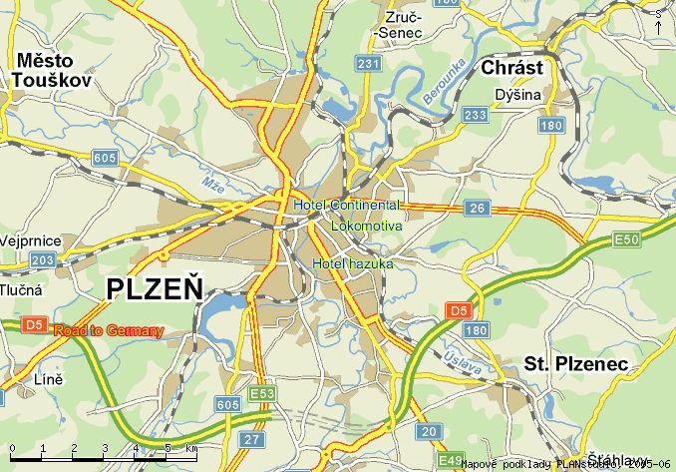

Marek Kubín Jan Pytlík

Organizing Commission president

of The Pilsen Karate Federation

e-mail: [kubin@karatecz.cz](mailto:kubin@karatecz.cz) e-mail: [pytlik@karatecz.cz](mailto:pytlik@karatecz.cz)